Link to past performances
Jan 3rd, 2026
Carnatic Classical concert – Bangalore, Raja Rajeshwari Cultural Association

- Friday, June 27, 2025
https://www.thekpac.org/events-calendar/kpac-beatles-reimagined-d8y2a-awzyk

Jan 17, 2025 Global music Night – Dark Room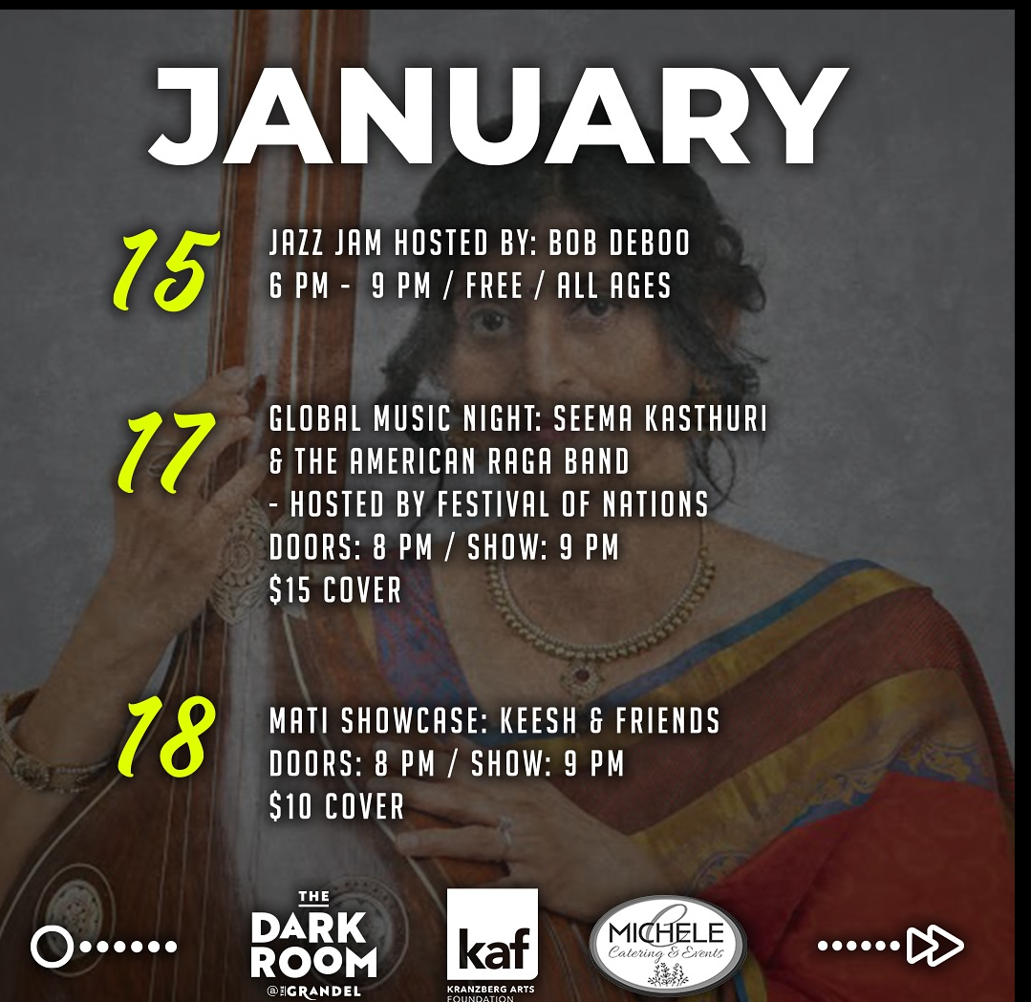

Aug 27th, 2024
Festival of Nations

